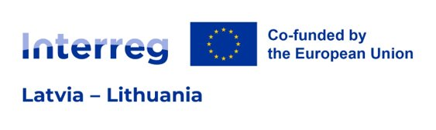
Project Confirmation Letter

Project ID
Project title
Project acronym
By submitting the Application Form filled in the Interreg VI-A Latvia-Lithuania Programme 2021-2027 (hereinafter – Programme) Joint Electronic Monitoring System (hereinafter – JEMS), the Lead partner (hereinafter – LP) on behalf of all partners confirms that:
- the Project respects EU requirements for joint development, joint implementation, joint financing and, if applicable, joint staffing;
- the Project, neither in whole nor in any part, has or will receive any other additional EU funds (except for the funds indicated in this Application Form) for the activities indicated in the Application Form during the duration of the Project;
- the Project activities indicated in the Application Form have not been implemented before the submission of this application;
- the Project partners listed in the Application Form are committed to take part in the Project’s activities and financing;
- the Project is in line with the relevant EU and national/regional legislation and policies of the regions and countries involved;
- the LP and the Project partners will act according to the provisions of the relevant EU regulations, the specific provisions of the Programme and national rules, especially regarding structural funds, public procurement, State Aid, equal opportunities and non-discrimination and sustainable development, and has no harmful impact on the environment;
- the information in the Application Form filled in JEMS of the Programme is accurate and true to the best knowledge of the LP;
- the LP and Project partners are aware of the Programme rules;
- the LP is authorised by the below mentioned organisation and participating Project partners to submit an application and sign the Subsidy Contract in the event of selection of the Project;
- All natural persons participating in the Project and Project activities have in advance given their consent to the collection, recording, storage and transfer of their personal data in databases of the Programme authorities and management bodies, as well as data transfer to third parties identified in the Programme's privacy policy (e.g., European Commission), in accordance with the provisions for data transfer and data processing described in Regulation 2016/ 679 (General Data Protection Regulation/ GDPR).
Name of organisation in English
Name of organisation in the original language
Legal address
Registration number | fgfgfdgfd
Name of the legal representative
Position
Signature
(not relevant for electronically signed document)
Date of signature
(for electronically signed document date of signature is in the signature’s time stamp)

Project Confirmation Letter must be completed by the LP organisation using this template and submitted electronically signed by electronic signature and attached to section “Attachments” in JEMS (e-signature time stamp must be within period of time from the opening till the closing time of the call). Detailed information on submission of application is specified in section 5.1. “Application requirements” of the Programme Manual of the Programme for the 1st call for proposals.

