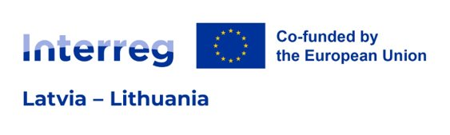
Lead Partner / Project Partner Statement
Project ID
Project title
Project acronym
In the event of approval of the above-mentioned Project applying to the Interreg VI-A Latvia – Lithuania Programme 2021- 2027 (hereinafter – Programme) the insert Lead partner and LP's name in English or Project partner No. X and PP's name in English (choose relevant):
- commits itself to the Project and the activities laid down in the Application Form, and intends to provide the total amount of EUR [insert amount] as partner contribution to the Project’s budget. The total eligible budget of our organisation within the Project is EUR [insert amount];
- is aware of the Programme rules on reimbursement and confirms the availability of own resources for pre-financing the activities and understands what its role will be in the Project;
- will provide financing to cover all ineligible expenditure which might occur during Project implementation;
- declares that it is not under a bankruptcy proceeding, bears full legal capacity and is financially reliable, and that its foundation and activities are in line with the respective national legislation;
- confirms that no expenditure related to the above-mentioned Project has been, is or will be funded, in part or in whole, by any other EU-funded programme;
- possesses sufficient human, financial and administrative capacity to implement the Project;
- will follow the principle of cooperation, will use Project’s resources in line with the principles of economy, efficiency, effectiveness and impartiality and the national, Programme and relevant EU regulations;
- has read the Programme Document and the Programme Manual and understands the role and obligations in the Project;
- confirms to undertake all necessary precautions to avoid situations leading to possible conflict of interest and corruption by following all relevant national laws and regulations;
- declares to accept all obligations as a [Lead partner or Project partner (choose relevant)] deriving from the Subsidy contract, which will be signed by the LP of the Project and the Managing authority of the Programme after the approval, as well as the Project Partnership Agreement which will be concluded between all partners participating in the Project;
- commits itself in complying with the relevant public procurement rules (internal, national, European and Programme specific rules if existing), communication requirements set in the Programme Manual and in making the Project results available to the public;
- will act according to the provisions of the relevant EU regulations, the specific provisions of the Programme and national rules, especially regarding structural funds, public procurement, State Aid, equal opportunities and non-discrimination and sustainable development, and has no harmful impact on the environment;
- confirms that the information in the Application Form is accurate and true to the best knowledge of the Project partner and LP.
Name of organisation in English
Name of organisation in original language
Legal address
Registration number
Name of the legal representative
Position
Signature
(not relevant for electronically signed document)
Date of signature
(for electronically signed document date of signature is in the signature’s time stamp)

Lead Partner /Project Partner statement must be signed by the authorised representative holding the right to sign documents on behalf of the LP or project partner organisation and uploaded to JEMS for the LP and each project partner as electronically signed document. Detailed information on submission of application is specified in section 5.1. “Application requirements” of the Programme Manual of the Programme for the 1st call for proposals.

