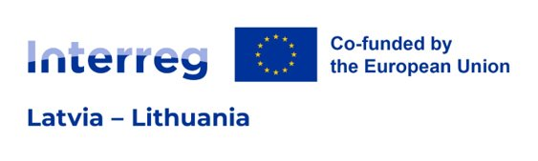
Project ID
Project title
Project acronym
Reporting period number
Reporting period start/end dates
ERDF co-financing requested

Confirmation for Project Report

By signing this Confirmation for Project Report the Lead Partner (hereinafter - LP) confirms that:
- the project neither in whole nor in part has or will receive any other additional European Union (hereinafter - EU) funding (except for the funding indicated in this Project Report) during the whole duration of the project;
- the project is in line with the relevant EU and national/regional legislation and policies of the regions and countries involved;
- the LP and the project partners have acted according to the provisions of the relevant national and EU regulations, especially regarding structural funds, public procurement, state aid, environment and equal opportunities, as well as the specific provisions of the Interreg VI-A Latvia–Lithuania Programme 2021–2027;
- the project respects equal opportunities and non-discrimination and has no harmful impact on the environment;
- information and documentation in this Project Report and its attachments give the correct description of the implementation and the current status of the project.
The official title of the LP organisation in English
Name and surname of the authorised representative
Position of the authorised representative

DOCUMENT IS SIGNED WITH SECURE ELECTRONIC SIGNATURE AND CONTAINS A TIME STAMP

Reporting period start and end dates are specified in the Contracting/Project Reporting Schedule.
Amount of requested European Regional Development Fund (hereinafter - ERDF) co-financing must match with amount indicated in the JEMS: Project Report/ Financial overview/table “Project expenditure - summary (in Euro)”/column “Current report (ERDF)”

