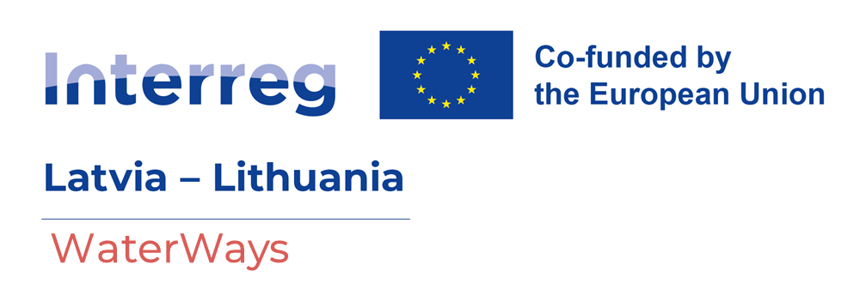

Project LL-00011: WaterWays

Development of the water routes network in Latvia and Lithuania by further expanding the cross-border tourism product www.riverways.eu

Presentation of the WaterWays Project Platform & Water Tourism Discussion
2025.10.07
Šiauliai region, Lithuania
AGENDA

10:00 – 10:30 | Registration  Restaurant „Ventragis“, Marių str. 24, Ventė, Šilutė district
10:30 – 11:00 | Project presentation  - The essence and goals of the WaterWays project  - Relevance for Lithuanian regions  - Opportunities for local tourism service providers
11:00 – 11:45 | Presentation of the Riverways.eu platform  - How the platform works  - Practical use: content, route search, integration of service providers  - Participant questions
11:45-12:15 | Coffe Break
12:15 – 13:30 | Discussion water tourism marketing in Lithuania and the region  - How to attract more tourists to rivers and waterways?  - The role of local businesses and municipalities  - Participant discussion – which services and routes should be integrated into the platform  - Questions and answers
13:30 | End of event

Registration until October 5, 2025: https://forms.gle/Y9n2E9E4SDGVUMcy9
More information – info@atostogoskaime.lt

